**Expose the deployment to internet**

**Step 1 : Describe services**

# kubectl get deployment



**Step 2 : expose the application behind load balancer**

# kubectl expose deployment python-deployment --type="NodePort"

# kubectl describe service python-deployment

**Step 3 : Describe svc**

# kubectl get svc

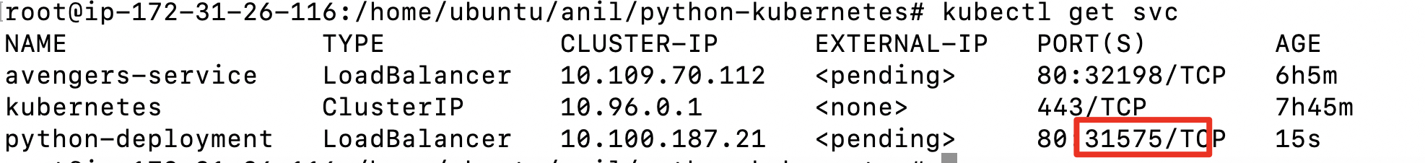

Use the PublicIp-ofmaster-node:31575 on your web browser to verify app is running

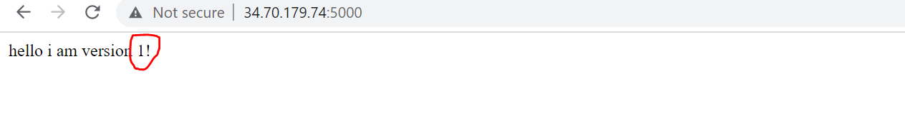

============================ completion of Lab =======================================